

**Czech-Austrian Winter and Summer School –New Storage Possibilities for REW**

**Radka Fabianova**

**Gerold Muggenhumer**

Co-operating Universities

   

Financial support by

 

**Prague and Vienna, 2012**

# Content

Content 2

Abstract 3

1 Introduction 3

2 Renewable Energy Sources 4

2.1 Photovoltaic 4

*2.1.1* *Potential of irradiation in Czech Republic and Austria* 5

*2.1.2* *Relationship between consumption and production* 6

2.1.3 Austrian-Czech legislation 8

3 Energy storage systems- A comparison 12

3.1 Lithium-Ion Batteries 13

3.1.1 Advantages of Lithium-Ion Batteries compared to predecessor technologies 13

3.1.2 How does Lithium-Ion batteries work 14

3.1.3 Resume 15

3.2 Small-scale Compressed Air Energy Storages (CAES) 16

3.2.1 Resume 18

4 Installation Model – An Island House 18

4.1 Description of the system 18

4.2 Requirements for appliances 19

4.3 Example of a reliable off-grid electricity system with batteries 20

4.3.1 Calculation of required energy capacity (batteries) 20

4.3.2 Mixture of parallel and series circuit 21

5 Conclusion 22

References 23

# Abstract

The objective of this work is to investigate the potential of RES especially photovoltaic to be a reliable source of energy in small-scale installations up to 30kW. So the efficiency in the Czech Republic and Austria must be shown, as well as the financial aspects. For saving electricity, small-scale compressed air energy systems as well as Lithium-Ion batteries are used to make photovoltaic a reliable source. This work also mentions off-grid solutions to demonstrate the reliability of storage systems.

# Introduction

Renewable energy sources are getting very popular in recent times and according to this also the installed RES power demand has grown immense. We are nowadays capable of producing cheap and green energy, but the question of reliability remains open.

The aim of the work is to describe and evaluate the reliability of photovoltaic systems as a source of electrical energy.

Nowadays it is not possible reliably supply the industrial sector, but there is a great potential for renewable energy in smaller installations for example for households and SMEs.

To make electricity from photovoltaic a reliable source it is required to be reliable in the quantity of electricity supplied, but also technically, financially and legislatively. These requirements are detailed in the introductory chapters of the work.

The heart of any solar system that should serve as a reliable supply of electricity is the way of storage. This issue will be discussed in a separate chapter and presented in it are different technologies that can be used for storage of renewable energy use. For a better understanding of solar energy as a reliable source of electrical energy will be introduced the existing off grid solar system, which forms the only source of energy for the house.

# Renewable Energy Sources

Nowadays there are many possibilities of producing almost (production process, recycling) green renewable electricity. But only a few have the potential to operate in small-scale systems. Despite this almost every detached house stands in an area with sun contact and wind. For its great technical and economic feasibility the main energy source in private building sector is photovoltaic. This source does have fluctuations in electricity production, which harms the predictability of the source and according to this, the reliability of renewable energy sources. So there must be energy storage systems that provide reliability for renewable energy sources which will be mentioned later in chapter 3.

## Photovoltaic

Our assumption is that photovoltaic can be a reliable source for small-scale installations together with appropriate storage system. But there are many points of view when we are investigating reliability. The main but not the only factor is the production potential of installation in considered region. In the case of photovoltaic we need to determine the irradiation at the installation site. As mentioned before, photovoltaic doesn’t produce electricity without fluctuations. For better understanding of photovoltaic in the meaning of energy source for households we have to describe the graph of their daily electricity consumption (Graph 3). And last but not least we have to take into account legislative and financial requirements of such installations because one of the assumptions of reliable source is its good availability.

### Potential of irradiation in Czech Republic and Austria

Important part of reliability of the photovoltaic systems is irradiation potential of each region. The image below represents a potential of both countries.

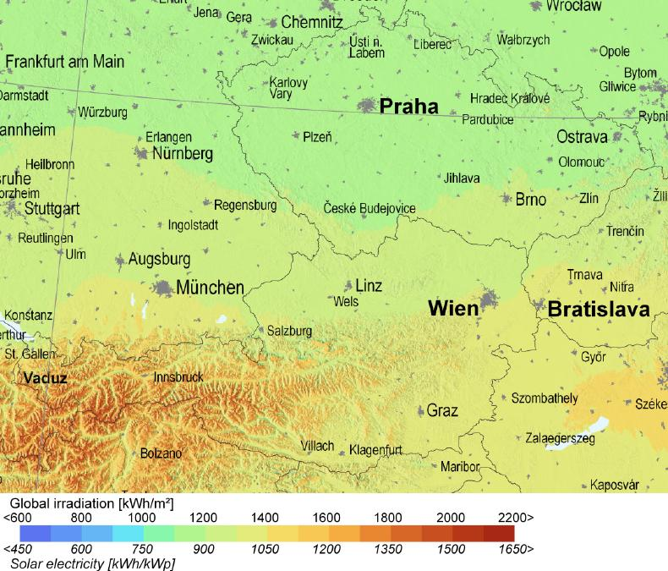

Image 1: Global irradiation[1]

It is clear that Austria is a much more convenient location for the production of electricity from solar panels. The difference is especially noticeable between the north of the Czech Republic and the south of Austria. If we take the example of Prague and Graz as pictured in Image , there is a difference in the intensity of radiation (kWh/m2) of about 15%.

But not only the geographical region is crucial for the magnitude of a photovoltaic energy production. Graph 1 display a 7.5 kWp mono-crystalline photovoltaic installation model in Eberstalzell (Latitude 48°2´38´´, Longitude 13°58´53´´), which is equal to the global irradiation of the northern area of Austria and the southern area of the Czech. The two scenarios mention the importance of the appropriate PV- panel installation. The differences of the two scenarios (best case, worst case) are basically the inclination and orientation angles of the panels. The best-case scenario is free- standing and has an **inclination angle of 34°** and the **orientation angle is 0°** (south orientated). On the other hand the worst- case scenario choose an **inclination angle of 45°** and an **orientation angle of -90°** (east- orientated) and is building- integrated. So there are also considerable differences in mounting (free-standing, building-integrated) of the panels. The placement in the difference of theses scenarios count about 5% (365,75 kWh) of the energy production per year. This is due to the temperature efficiency losses of the panels.

Graph 1: The installation importance [2]

### Relationship between consumption and production

When we rely on the generation of electricity using photovoltaic panels we need to keep in mind the important features, which this type of production brings with it. We must focus at what period, whether annual or daily is produced the most electricity and at what period on the other hand is the most of the energy consumed. A detailed representation gives us the graphic below.

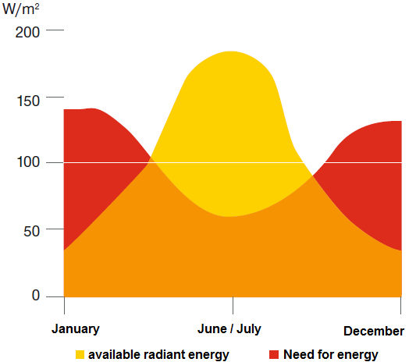

Graph 2: Consumption vs. production[3]

It is also important to realize about what kind of consumption we are talking about. We can distinguish between household consumption, which is the largest in the morning and afternoon (Graph 3). In contrast, consumption of companies (Graph 4) creates with the production of solar energy a good match. For example, air conditioning is most used at a time when the manufacture of photovoltaic panels is greatest. The graphs below compare the consumption patterns of both household use and businesses.

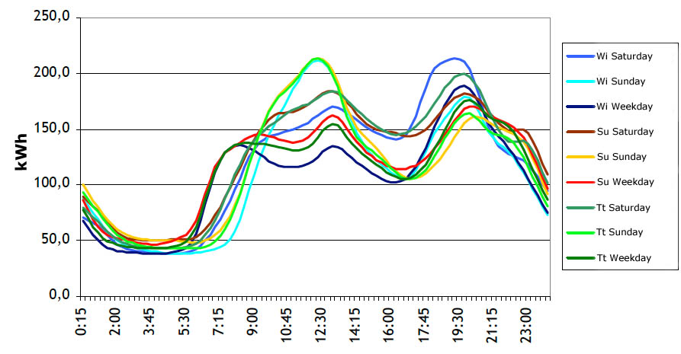

Graph 3: Daily consumption profile of a household[4]

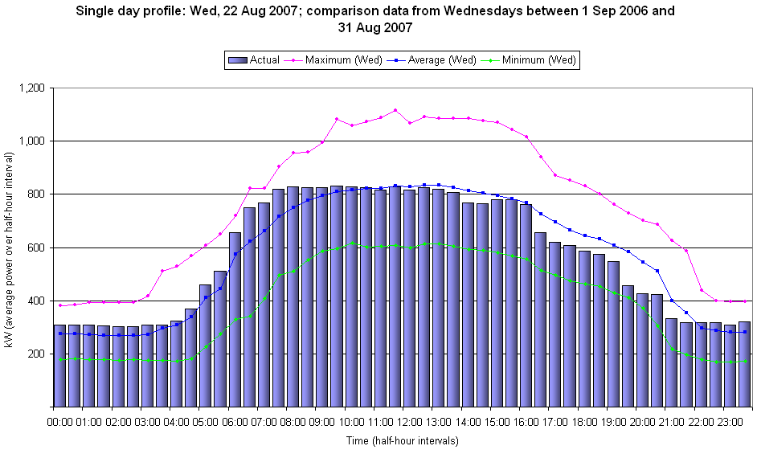

Graph 4: Daily consumption profile of a company[5]

### Austrian-Czech legislation

For the purpose of our work we consider off grid installation, which meets minimum of the legislative constraints. However, if the installation is connected to the distribution network, there are several regulations, which need to be followed in both countries. The purpose of this subchapter is to determine whether the conditions are the same in both countries or if any of the countries is more favourable for the construction of photovoltaic installations.

#### Czech Republic Legislation

As we mentioned in the introduction chapter, if you opt for off-grid installation you do not need any permission from the “Energy Regulatory Office” or from the local electricity distributor. It could be possible that the off grid installation will be subject to some restrictions in the form of a local building permit or construction notification to the local office. If the excess power from the panels will be delivered to the network there is need for several permits. First, you need to apply for the connection to the local distribution system. Than apply for a license by the Energy Regulatory Office:"Application for a license for business in the energy sector for natural / legal persons”. An applicant for a license must be identified by personal identification number and permanent residents according to the data in identity cards. Based on the identification of the applicant one will be given an identification number. The general conditions of the permit are a criminal integrity, 18 years of age and full legal capacity. If an installed capacity exceeds 20 kWp another prerequisite is the assumption of competence. If it does not directly from the applicant the competence must provide a responsible representative. The application must also state the estimated time required for business and the period of time for which the license should be granted. The applicant must demonstrate the property rights and satisfy technical assumptions. Ownership must be documented with the right of ownership or the right of use. Technical requirements – building approval shall be demonstrated for new energy facilities over 20kWp. You must also pay an administrative fee of CZK 1000.[6]

If the excess energy supplied to the network, its purchase price is favored.

Purchase prices for electricity from renewable energy sources (RES) put into operation in 2012 are set so that the lifetime of the various types of renewable electricity producers will ensure fifteen years guaranteed return on investment.[7]

In the Czech Republic we can distinguish two types of benefits. Green bonus and guaranteed purchase price.

You get green bonus if you sell the excess energy of the photovoltaic power plants to the distribution system. Green bonus applies for all energy produced - including the one that is consumed. You don´t pay to your supplier for your consumption, but you have to find the buyer who will take the excess energy from you. Guaranteed purchase price of energy means that the distribution system operator is obliged by law to purchase all electricity produced by solar power. But you have to pay to supplier for your energy costs.[8]

Purchase price for solar power plant to 30 kW built in 2012 is 6160 CZK/MWh (246,4 €/MWh [9]) and the green bonus is 5080 CZK/MWh (203,2 €/MWh [10]).

#### Austrian Legislation

Photovoltaic like other electricity producing installations, impervious whether they are on- grid or off-grid basically fall nationally within the scope of the “Elektrizitätswirtschafts- und Organisationsgesetz (EIWOG)” and hence they behoove to the respective states. So it depends on the state where the photovoltaic system is getting installed. For this work we used Styria (capital is Graz). The “EIWOG” basically regulates the construction, announcement as well as the application for permit of a photovoltaic system. Another important law is the “Ökostromgesetz”. It treats the definition of “green” energy and also the amount of national funding. According to the latest edition of the “Ökostromgesetz” (ÖSG 2012), a funding of 8 mill. Euros is provided for photovoltaic applicants in Austria.

##### Requirements for funding

* PV- installation has to suffice §7 “Ökostromgesetz” 2012
* Installation from a permitted expert company
* Assignment of a expert company before application for permit
* only on-grid PV-systems
* more than 50% of the building must belong to private use
* latest technique
* only one application per applicant
* application for permit before delivery of the PV- system

##### Styrian funding

The Styrian legislation distinguishes between smaller PV-systems up to 5 kWp and one with more than 5 kWp. The Styrian funding system also distinguishes between communities. For simplicity we used the common Styrian model.

* **Photovoltaic System up to 5 kWp**

Table 1: Styrian PV funding

|  |  |  |  |
| --- | --- | --- | --- |
| Basic funding | | | |
| Number of accomodation units | conveyable Power in kWp | Funding amount in Euro | |
| Funding without KLIEN | Funding with KLIEN |
| total | total |
| Rebuilding or expansion of PV-systems up to 2 accomodation units | 2 extended | 500,- | 375,- |
| 2 new | 750,- | 562,5 |
| 2,5 extended | 625,- | 468,75 |
| 2,5 new | 875,- | 656,25 |
| 3 | 1.000,- | 750,- |
| 3,5 | 1.125,- | 843,75 |
| 4 | 1.250,- | 937,5 |
| 4,5 | 1.375,- | 1.031,25 |
| 5 | max 1.500,- | max 1.125,- |
| Rebuilding or expansion of buildings from 3 accomodation units | 2 | 750,- | KLIEN only from 2 to 5 kWp! |
| per extended 0,5 kWp | 125,- |
| max. 15 | 4.000,- |
| surcharges | | | |
| Rebuilding | additional basic amount | 500,- | 375,- |

* **Photovoltaic system greater than 5 kWp**

On-grid PV-systems with more than 5 kWp are getting subsided in the context of the “Ökostromgesetz” (ÖSG; BGBl. I Nr.149/2002 idF. BGBl I Nr.104/2009) with a continuously feed-in tarif for 13 years. The whole produced energy of the PV- system is injected into the electricity grid

Table 2: feed-in rate of PV-systems greater than 5 kWp in Austria

|  |
| --- |
| **For PV- systems, solely installed on buildings** |
| > 5kWp up to 20kWp | 29,45 Cent/kWh |
| > 20kWp | 26,40 Cent/kWh |
| **For PV- systems, not solely installed on buildings** |
| > 5kWp up to 20kWp | 27,65 Cent/kWh |
| > 20kWp | 20,63 Cent/kWh |

# Energy storage systems- A comparison

In this paper we consider the needs especially for household and public building sector up to 20 kW. As mentioned before, an energy storage system in households has to achieve certain important criteria. They must be reliable for few days and the storage duration has to be short. So we took our attention to two energy storage systems, which fulfil the specification criteria for these areas.

Energy storage systems for households and small-scale systems are available in a huge diversity of different techniques (Image 2). Energy can be stored as kinetic energy (flywheel), chemical energy, compressed air, hydrogen (fuel cells), or in supercapacitors or superconductors and of course in batteries.

**Energy storage techniques can be classified as follows:**

* According to the type of application: permanent or portable
* Storage duration: short or long term
* Type of production: maximum power needed

This chapter mentions the pro and cons of CAES and Lithium-Ion batteries according to the economical view, and should give the reader an overview of technical aspects.

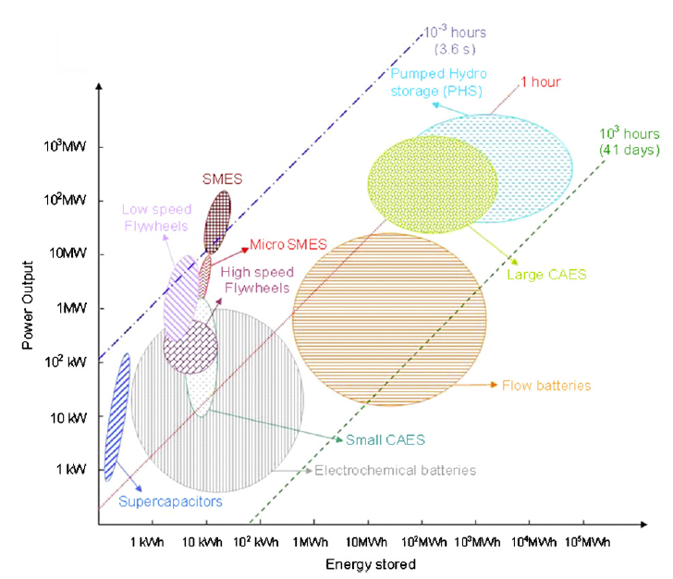

Image 2: Discharging energy capacity in a timescale[11]

## Lithium-Ion Batteries

The latest available battery technology regarding especially to on-grid PV- systems are lithium-ion batteries. This technology has an essential improvement in lifetime capacity compared to current techniques like lead-gel batteries. Also a very important improvement compared to lead-gel accumulators is that they are completely maintenance-free.

The latest researches offer a lifetime with about 20 years and an efficiency grade of 95%. With at least 5 kWh, they only need a volume of 50 liters so they are also very suitable for small-scale systems like residential PV-systems.

### Advantages of Lithium-Ion Batteries compared to predecessor technologies

* high lifetime up to 20 years without maintenance
* discharge depth up to 100%
* high energy density (less weight, less volume)[12]

### How does Lithium-Ion batteries work

The negative electrode (cathode) is basically built up of a lithium-metal oxide on an aluminum collector. The anode mainly consists of graphite on a copper collector. The Separator sorts the anode out from the cathode and therefore prevents an inner short- circuit. Lithium-Ions can pass the Separator because of its blown structure. In the charging period of the cells, the Lithium-Ions move from the cathode through the electrolytes to the anode. In the discharging period, the Lithium-Ions move back from the anode to the cathode whereby electricity is set free.

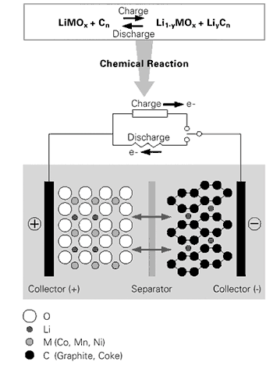

Image 3: Bssic principle of Lithium-Ion[13]

### Resume

Lithium-Ion Batteries are getting very popular in recent times, especially for automotive sector as well as for renewable energy sources as energy storage. Altogether the advantages prevail the disadvantages. Only the price factor can play a major role nowadays to prefer predecessor technologies like lead-gel, but some literatures argue that according to the long lifetime and maintenance freeness also in recent times Lithium-Ion batteries can be cheaper than older techniques.

## Small-scale Compressed Air Energy Storages (CAES)

The ability to efficiently harness and utilize renewable, intermittent energy sources such as photovoltaic is critically depending on the availability of cost-effective energy storages systems. Large-scale CAES such as Huntdorf in Germany are already operational and use underground caverns for compressed air storage. In such systems, typically, natural gas or other fuels are used for the expansion phase of the compressed air. The efficiency of large-scale CAES is about 60% and has high-energy power densities.

The energy storage capabilities of CAES systems can be easily understood in terms of the first law of thermodynamics, where the energy produced by an external source (PV panel) is used in compressing air. The compression process can occur under many different conditions: if the compression is isothermal, then the temperature of the system doesn´t change, if on the other hand the system is adiabatic, then the change in heat content doesn´t change.

Image 4 demonstrates the working principle of compressed air energy storages. The residential PV- panels operate the “Hybrid Unit”, which compresses the air under isothermal conditions. With isothermal conditions better efficiency can be reached as well as less energy is needed to compress the air (Image 4).

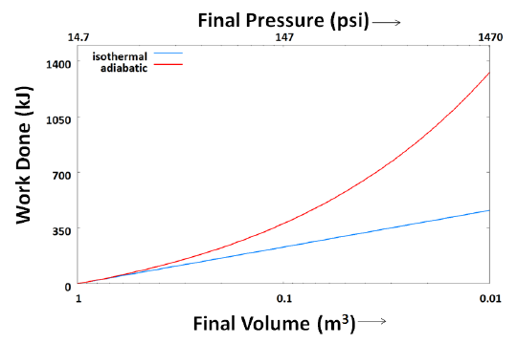

Image 4: Work done to compress 1m3 air under different conditions[14]

The “Hybrid Unit” has according to the work of Villela D. et. al (2010) the advantage to decrease energy losses, due to the reduction in number of moving parts/components for the multi-stage conversion of solar energy to compressed-air or to powering household appliances.

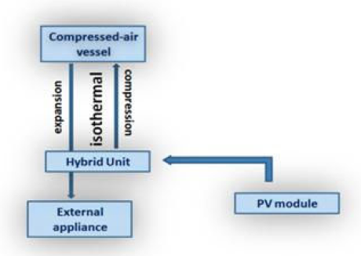

Image 5: Schematic of a SS-CAES[15]

Villela D. et al (2010) built a SS-CAES prototype, which is tailored to operate with residential PV- panels. The power output of such panels typically ranges up to 160W (Watt), which may not be conducive for operating commercial compressors. Image 6 illustrates the developed prototype of Villela D. et. al (2010).

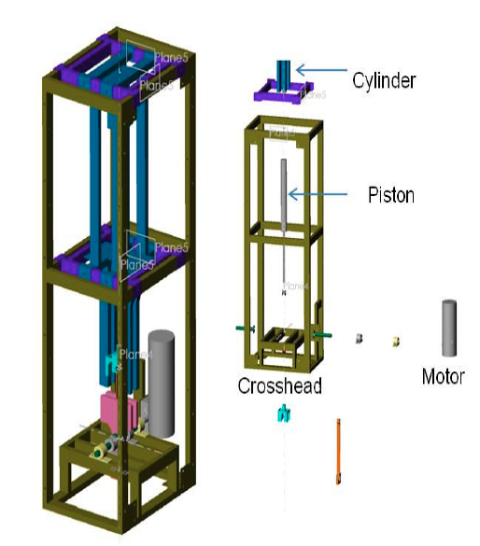

Image 6: Developed compressor prototype for residential PV-panels according to Villela D. et. al (2010)[16]

They designed a singe-stage, displacement-based, piston-driven, small-scale, low-cost, compressor that has the capabilities of functioning at low compression rates (rpm= 10-60). An important feature of this compressor is its ability to operate under isothermal conditions. The efficiency of such a system strongly depends on the rpm of the compressor. In the work of Villela D. et. al (2010) the reported efficiency ranges between 40-70 % (quasi-isothermal).

### Resume

Small-scale CEAS represent an important step towards a storage system that can work seamlessly with PV panels and therefore this technique can be a low-cost efficiently and environmentally friendly storage system for decentralized, or off-grid electricity systems. Unfortunately, there has to be done further research to make this smart technique available to the market.

# Installation Model – An Island House

The best example to demonstrate the reliability of electricity produced by photovoltaic panels is to show it connection with off-grid installation. In the next chapter we will introduce one such solar power project that supplies a family house with electricity. We will describe what characteristics you need to consider in building such a facility and what restrictions it brings.

It is necessary that the electricity production from panels cover a three-member household consumption. The standard electricity consumption pattern of this family is slightly different because the parents work at home, so even during the day there is a consumption of electricity.

## Description of the system

The size of the system should be set to at least to the 90% of consumption in the winter but not higher. It is not advantageous to design a larger system, because in the summer, when production of the photovoltaic power plants is the largest, would not be any use for the produced energy. Energy intensity of this house in winter is around 4 - 7 kWh. Installed capacity of power plant is 7,5 kWp and consists of 54m2 panels of amorphous silicon.

It is also necessary to adjust the system for appliances with high starting currents. The estimation amount of the maximum instantaneous power is necessary to set the power of the inverter.

Crucial for the whole system is the choice of battery. The various types of batteries have been described in the previous chapter. Now we only mention what influences the choice. As usual appliances work on 230V, it is advisable to choose the battery voltage of 24V, 36V or 48V. For this installation was chosen a battery with voltage of 24V. An important property of a battery is its guaranteed number of cycles, because it indicates how long the battery lasts. It is also important to choose the right capacity of the battery. If we choose too small capacity, the energy accumulated in it is not enough to overcome the period without the sun and the battery is also more exposed to charge and discharge, which will reduce its life. The capacity of the battery installed in the house is designed to cover a 5-day consumption of the house. In practice, this will cover only one-day operations for several reasons. In particular, the discharge of the battery should not be more than 80%, because the greater discharging reduces its lifetime. Batteries should also be fully charged before discharging, which may not be achieved in daily use. Also the loss of the inverter and of the battery age is decreasing its accurate capacity.

The system needs to charge the battery even when solar power does not produce energy. As a back-up was installed diesel generator system. It should have an automatic start, because the system is monitored by an industrial machine. The system itself is otherwise maintenance free, just need to sweep the snow from the panels in winter and add fuel to power generators.

## Requirements for appliances

The cheapest energy is the non-produced and therefore the consumption of the whole house is adapted to the nature of the production of electricity from solar panels. First you need to install the most possible saving appliances, not only appliances with high energy demand such as the refrigerator, but we also need to consider lighting. LED lights and energy saving lights appears to be the most suitable. When designing the system, you need to replace electricity wherever it generates heat - that is for cooking, heating and water heating. You can´t just think of the obvious appliances such as appliances for cooking but also for example washing machines. Today you can buy a washing machine with a separate supply of hot water, which is really helpful to the system.

Appliances in general can be divided into three groups according to their consumption. The first group consists of appliances, which must always work. These include a refrigerator, TV, computers, lighting. Another group consists of appliances, whose consumption can be postponed until the plant produces enough electricity - dishwasher, well pumps or washing machine. Due to the nature of solar power can be assumed that in the summer the power station will produce in abundance. Therefore there is need to have appliances that consume the surplus of electricity. The system described here uses for this purpose heating of water in the house or pool.

## Example of a reliable off-grid electricity system with batteries

For this work we suppose a household with several appliances:

* 15 LED lights with 18W each and operation time of 4hours
* TV with 60W and an operation time of 3 hours
* Computer with 60W and an operation time of 4 hours
* Fridge with 0,0026 kWh[17]
* Washing machine 0,40 kWh (every second day, else 0,8 kWh)[18]

As mentioned before other appliances, especially warm water supply, or cooking (gas) are operated with other sources, due to this can be realised more efficient.

### Calculation of required energy capacity (batteries)

|  |  |  |  |  |
| --- | --- | --- | --- | --- |
| **Amount** | **Appliance** | **Power/ peace** | **Operation time** | **Energy/ day** |
| 15 | LED- lamps | 18 Watt | 4 hours | 1,08 kWh |
| 1 | TV | 60 Watt | 3 hours | 0,18 kWh |
| 1 | Computer | 60 Watt | 4 hours | 0,24 kWh |
| 1 | Fridge | - | - | 0,0026 kWh |
| 1 | Washing machine | - | - | 0,40 kWh |
| **Total energy demand for one day** | | | | **1,91 kWh** |

To offer a save and reliable energy systems, it must also be included in the calculation process that there are some rainy or foggy days without sun irradiation. For this work we assume 5 days of extra capacity to ensure save energy supply.

|  |  |  |
| --- | --- | --- |
| 1,91 kWh | x 5 days | = **9,55 kWh** |

|  |  |  |
| --- | --- | --- |
| 9,55 kWh | : 0,7 | = **13,65 kWh** |

According to chapter 3.1 we assume a discharging of the Lithium-Ion battery of 70%

To get the battery capacity it has to be chosen weather to take 12 Volt or 24 V batteries. In this work we chose 24 Volt to decrease the size of the batteries.

|  |  |  |
| --- | --- | --- |
| 13,65 kWh | : 24V | = **569 Ah** |

* **Series circuit of batteries**

If batteries are connected in series, the voltage of each battery cell sums up to the total storage voltage.

* **Parallel circuit of batteries**

On the other hand, if batteries are connected parallel, the capacity (Ah) of each battery cell sums up to the total storage capacity.

### Mixture of parallel and series circuit

Such a required system can be reached by merging 2x four 75 Ah batteries parallel each and connect them in series, so 8x 75 Ah batteries are required to support such a off-grid system to be reliable for 5 days.

# Conclusion

Decentralized energy systems are very helpful for the electricity grid, if efficient storage systems are available and used. There are a lot of current available storage techniques, but the questions of convenient ones remain open. As in Chapter 2 illustrated, the geographical installation of a PV- system is essential as well as the respective legislation. We took attention to two storage systems, which we think are suitable and effective for storing electricity regarding to residential- PV-systems. The two mentioned storage techniques Lithium-Ion and small-scale CAES are in research, but especially for low-cost installations they have a high potential. This field of research is still very new, but very important for the electricity grid, the economy as well as for the environment. A lot of companies are researching and investigating new possibilities to store electricity. And also the governments all over the world are getting recently, according to Fukushima, very ambitiously to accelerate technological improvements.

# 

# References

BizEE Software Limited, Energy lens

<http://www.energylens.com/outputs>, 3.06.2012

Conergy Energiespeicher, Sonnenstrom bei Tag und bei Nacht

<http://www.conergy.de/Portaldata/1/Resources/de/pdf/Sonnenspeicher_LF_GER_110601_web.pdf>, 8.06.2012

European Commission, Joint Research Center

<http://re.jrc.ec.europa.eu/pvgis/apps4/PVcalc.php>

European Commission, Photovoltaik Solar Electricity Potential in Europen Countries

<http://re.jrc.ec.europa.eu/pvgis/cmaps/eu_opt/PVGIS-EuropeSolarPotential.pdf>, 3.06.2012

Ibrahim H., Ilinca A., Perron J., Energy storage systems-Characteristics and comparisons, Elesevier, Renewable & sustainable energy reviews, 2007

Villela D., Kasinathan V., De Valle S., Alvarez M., Frantziskonis G., Deymier P., Muralidharan K., Compressed-air energy systems for stand-alone off-grid photovoltaic modules, 2010

Michael Lippert, Saft Industrial Battery Group, Holger Schuh, Saft Batterien GmbH (without data), Batterien als Energiespeicher zur Förderung von PhotovoltaikEigenverbrauch im Smart Grid der Zukunft - Das Sol-ion Projekt

<http://www.saftbatteries.de/pdf/SmartGrids-2.pdf>, 3.6.2012

Photovoltaik-Web.de, Hersteller Speicherlösungen,

<http://www.photovoltaik-web.de/batteriesysteme-akkusysteme-pv/hersteller-speicherloesungen.html>, 8.06.2012

Spiegel Online, Solar- Riesen packen die Sonne in den Keller,

<http://www.spiegel.de/wirtschaft/akku-offensive-solar-riesen-packen-die-sonne-in-den-keller-a-692721.html>, 7.06.2012

Wirtschaftskammer OÖ (n.y), Standardisierte Lastprofile,

http://www.google.at/url?sa=t&rct=j&q=lastprofil%20haushalt%20strom&source=web&cd=4&ved=0CHQQFjAD&url=http%3A%2F%2Fportal.wko.at%2Fwk%2Fdok_detail_file.wk%3FAngID%3D1%26DocID%3D603304%26...&ei=zCatT7DKEIKPswa98JWHDA&usg=AFQjCNEvQEkq8NT2mR7grP_CkxjJA_UreA, 10.05.2012

Varta, Development of the battery,

<http://www.varta-automotive.com/index.php?id=90>, 9.06.2012

VYUŽITÍ SLUNEČNÍ ENERGIE. In: *Obnovitelné zdroje a skupina ČEZ* [online]. [cit. 2012-04-20]. Avalaible from: http://www.cez.cz/edee/content/file/pro-media-2012/03-brezen/ obnovitelne-zdroje-energie-a-skupina-cez.pdf

http://eru.cz/user_data/files/licence/info_pro_zadatele/metod_pokyn_011_2009.pdf

http://www.spvez.cz/pages/podpory.htm

<http://www.zeleny-bonus.eu/statni-podpora/>

1. http://re.jrc.ec.europa.eu/pvgis/cmaps/eu_opt/PVGIS-EuropeSolarPotential.pdf
2. http://re.jrc.ec.europa.eu/pvgis/apps4/PVcalc.php
3. VYUŽITÍ SLUNEČNÍ ENERGIE. In: *Obnovitelné zdroje a skupina ČEZ* [online]. [cit. 2012-04-20]. Avalaible from: http://www.cez.cz/edee/content/file/pro-media-2012/03-brezen/ obnovitelne-zdroje-energie-a-skupina-cez.pdf
4. Wirtschaftskammer Oberösterreich (n.y)
5. http://www.energylens.com/outputs
6. http://eru.cz/user_data/files/licence/info_pro_zadatele/metod_pokyn_011_2009.pdf
7. http://www.spvez.cz/pages/podpory.htm
8. http://www.zeleny-bonus.eu/statni-podpora/
9. exchange rate 25 CZK/€
10. exchange rate 25 CZK/€
11. Ibrahim H. et. al (2007)
12. Conergy Sonnenspeicher
13. Varta Automotive
14. Villela D. et. al (2010)
15. Villela D. et. al (2010)
16. Villela D. et. al (2010)
17. Miele K 9252i-1 (152 l)
18. Miele W 1904 Eco Active